UBND THÀNH PHỐ HỒ CHÍ MINH | CỘNG HÒA XÃ HỘI CHỦ NGHĨA VIỆT NAM
TRƯỜNG CAO ĐẲNG LÝ TỰ TRỌNG | Độc lập - Tự do - Hạnh phúc
THÀNH PHỐ HỒ CHÍ MINH
ĐỀ THI KẾT THÚC HỌC PHẦN LÝ THUYẾT
HỌC KỲ: II NĂM HỌC: 2017 – 2018

Bậc đào tạo: TRUNG CẤP Học phần: NGHE
Lớp: 17T4-………… Ngày thi: ___ / ___ / 2018
Thời gian thi: 45 phút (không kể thời gian phát đề)

HỌ VÀ TÊN SV |  | Chữ ký Giám thị I | Chữ ký Giám thị II | Số mật mã
LỚP | SỐ KÝ DANH | Chữ ký Giám thị I | Chữ ký Giám thị II | Số mật mã
-----------------------------------------------------------------------------------------------------------------------------
Chữ ký Giám khảo I | Chữ ký Giám khảo II | ĐIỂM BÀI THI |  | Số mật mã
 |  | (bằng số) | (bằng chữ)
1. Hướng dẫn làm bài
Đề số 002

Thí sinh không được sử dụng tài liệu khi làm bài.
Sinh viên làm bài ngay trên đề thi.
Bài thi này gồm 40 câu, mỗi câu 0.25 điểm.

2. Nội dung đề thi

Task 1: Listen to the dream catcher legend.
Number the sentences in the correct order from 1 to 8. Listen two times. (2pts)
_____ One day, her grandson came in and saw the spider.
_____ The spider said, “Now you will have only good dreams.”
_____ The grandmother asked her grandson not kill the spider.
_____ A grandmother was watching a spider making a web.
_____ The spider said, “I will give you a gift.”
_____ The spider thanked the grandmother for saving his life.
_____ He picked up a shoe to hit the spider.
_____ The spider had made a beautiful web near the window.

--------------------------------------------------------------------------------------------------------------------------------------------------
Task 2: Which statement about each telephone call is true?
Listen and circle the correct answers. Listen two times. (1.5pts)

- a. Mr. Grant is funny. 4. a. Wendy’s boyfriend is very serious all the time.
b. Mrs. Grant loves to have fun. b. Wendy loves to have fun.

2. a. Neither brother likes studying. 5. a. Both teachers are very easygoing.
b. Both brothers go to school everyday. b. Both teachers just started teaching at the school.
3. a. Mr. Robert doesn’t talk a lot. 6. a. The wife finishes work earlier than her husband.
b. It’s difficult to talk to Mrs. Roberts. b. The husband works as hard as the wife.

Task 3: People are talking about health problems.
Listen and number the pictures. Listen two times. (1.5pts)

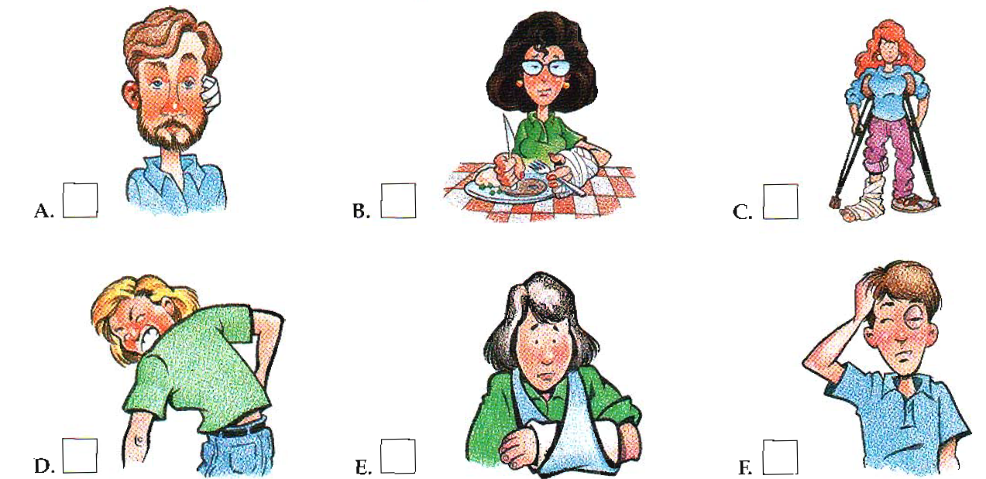

Task 4: Listen. What decision are the people trying to make? Number the decisions from 1 to 5.
There is one extra decision. Listen twice. (1.25pts)
_____ buying a car _____ getting a job _____ living alone
_____ buying a house _____ getting married _____ travelling abroad

Task 5: Listen and fill in the blanks. Listen three times. (3.75pts)
In my (1) ………………….., we have (2) ……………………..of (3) ……………… Day. It’s on the second Monday in January. The year we (4)………………….. twenty years old, we (5)…………………….. this day. We (6) …………………….. up. Women wear long, colorful dresses (7)………………….. kimono, and men wear (8) ………………….. There’s a big (9) …………………… at City Hall, and somebody usually makes a (10)…………………… But the fun (11)…………………….. is having a party with our friends. We’re twenty. We’re finally adults.
For me, becoming an adult was my Quinceanera party. Quince means “fifteen”. Where I come from, this is very (12)…………………. for fifteen-year-old girls. We wear pretty white dresses, and we usually wear something pretty in our hair, too – a hairpiece. First, we go to (13)……………………., then we have a big party and dance. We always dance the first dance with our fathers. Quinceanera means we are no (14)………………… (15) ……………….. girls. We are becoming women.
______Hết_______
GHI CHÚ: CÁN BỘ COI THI KHÔNG ĐƯỢC GIẢI THÍCH GÌ THÊM.

TRƯỞNG KHOA GIẢNG VIÊN RA ĐỀ

Trần Kim Thu Liễu Nguyễn Thị Bảo Trân

